Eth PAura



Software Design Specification

HEC mitigation

And

Information sharing System

**Information & Communication Technology**

**Rajarata University of Sri Lanka**

**Faculty of Applied Sciences**

1. **INTRODUCTION**
   1. **Purpose**
   2. **Document Conventions**
2. **ARCHITECTURAL DESIGN**
   1. **High level components and their interactions**
      1. **Component (Sub-System) Design**
      2. **Components**
      3. **Interfaces**
   2. **Architectural styles / patterns**
      1. **Layered Architectural Style**
   3. **physical arrangements of devices**
   4. **design decisions**
      1. **MVC (Model-View-Controller) development style is been used**
      2. **Object Oriented Software development method is used**
      3. **AJAX (Asynchronous JavaScript and XML) is used**

1. **COMPONENT AND DETAIL DESIGN COMPONENT AND DETAIL DESIGN**
   1. **design patterns**
      1. **Prototype Pattern**
      2. **Observation Pattern**
      3. **Composite Design Pattern**
      4. **Strategy Design Pattern**
   2. **Class Diagram**
   3. **sequence diagrams**
      1. **HEC part**
         1. Subscribe
         2. Register
         3. Send Push SMS
         4. Detect Thret and Thret msg Processing
         5. Send threat msgs to server
         6. Start Ultra sound wave
         7. Stop Ultra sound wave
         8. Receive data from safe zone detectors
         9. Process critical treat msgs
         10. Start alarm
         11. Stop alarm
         12. Notify Wild Life
         13. Ask backup
         14. Ask for a doctor
         15. Take Assignment
         16. Compose Safety msgs
      2. **Analyser Part**
      3. **Web part**

* 1. **Algorithm Design**
  2. **Database design**
     1. **Relational Model**
     2. **Normalization/Denormalization**
     3. **Data Dictionary**
     4. **Decisions made to manage transactions concurrent**
     5. **Indexes**
  3. **User interfaces**
  4. **Rules and guidelines for interface design**
     1. **User interface design framework**
     2. **User Input validation methods**
     3. **Alert messages decomposition**
  5. **User interfaces design**
     1. **HEC part**
        1. Subscribe
        2. Register
        3. Send Push SMS
        4. Detect Thret and Thret msg Processing
        5. Send threat msgs to server
        6. Start Ultra sound wave
        7. Stop Ultra sound wave
        8. Receive data from safe zone detectors
        9. Process critical treat msgs
        10. Start alarm
        11. Stop alarm
        12. Notify Wild Life
        13. Ask backup
        14. Ask for a doctor
        15. Take Assignment
        16. Compose Safety msgs
     2. **Analyzer part**
     3. **Web part**
        1. Login
        2. Register
        3. Edit User Profile
        4. Change password
        5. Comment
        6. Remove Comment
        7. Edit Comment
        8. Add photo
        9. Remove photo
        10. Add Video
        11. Remove video
        12. Add posts
        13. Edit posts
        14. Delete Posts
        15. Upload Document
        16. Delete Document
        17. Ask Questions
        18. Delete Questions
        19. Edit Questions
        20. Answer Questions
        21. Edit Answer
        22. Download
        23. Remove User
        24. Add User
        25. Change Priviledge levels by admin
        26. Remove posts by admin
        27. Edit Comments By admin

**1. INTRODUCTION**

**1.1. PURPOSE**

This is the Software Design Specification version 1.0 of the third year project, “” also called the “ETHPAURA”. This document covers the all the design aspects of the project starting from the high level components of the system to the class level design. It also includes the sequence diagrams and necessary UI mockups of the project.

This document is intended to be referred frequently in the implementation phase, since this document forms the concrete basis for the implementation.

**1.2. DOCUMENT CONVENTIONS**

|  |  |  |  |
| --- | --- | --- | --- |
| Heading Style | Font Size (pt.) | Font Type | Font Color |
| Master Headings | 13 | Times New Roman | White |
| Sub Headings | 12 | Times New Roman | Black |
| Other Headings | 11 | Times New Roman | Black |
| Body | 10 | Times New Roman | Black |

**2. ARCHITECTURAL DESIGN**

**2.1. HIGH LEVEL COMPONENTS AND THEIR INTERACTIONS**

**2.1.1 Component (Sub-System) Design**

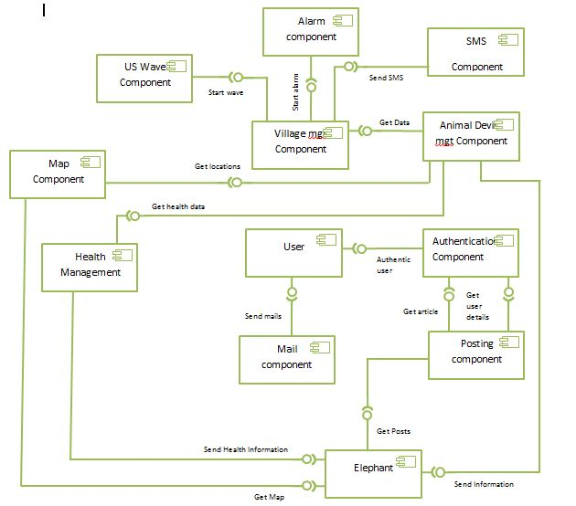

**2.1.2 Components**

1. Map component

This component has internal functionality of handling maps. Here we use algorithms to simplify and optimize the use of map component. This component in that sense is responsible for handling all map related functions.

2. SMS component

SMS component will be called when there is a need for sending bulk or single SMS s. We hope to use two hosted SMS API from a service provider to implement this feature.

3. Health component

Basically this component is responsible for keeping and handling health related data. Will get the service from Animal Device Manager Component and will mainly provide service to elephant component.

4. User Authentication component

This component can be introduced as one of the key component in the system which bears the burden of security. And group based action restrictions. In that sense this will work as a gateway and will route users along their authorized parts of the system.

5. Mail component

Emailing component is responsible for single or bulk emails when needed. Other components can request the service from this component when needed. All the web registered users are supposed to have an email entered.

6. Village component

This can be identified as a critical component. In the whole system responsible for handling data related to the villages, including whom to notify, when a threat what to notify, when to start other components as necessary. Will serve mainly to elephant device.

7. User component

The main subsystem that has the internal functionality of handling and managing student related data. This component will maintain necessary categorization regarding users. Also this component is responsible for giving services to many other components as well.

8. Posting component.

This component is responsible for publishing posts. Also this is capable of handling multiuser posts. Some of the posts are automatically published by other components such as elephant component. And some of the posts published by users.

9. Elephant component

Main component responsible for all the underline processes in web part. This component is responsible for handling and managing all the tasks related to elephants. Take the use of other components such as mail component etc. and give its service to other components such as post component.

10. Elephant Device Component

Main task of this component is to interpret the data between outside and the system. Will control the data formats and data set sending to the inner system. This is the main controlling body of the system.

**2.1.3 Interfaces**

Since this system implemented as tight MVC style there will be well defined interfaces between models, controllers and views. But for the sake of modularity, we’ll define some interfaces to breakdown the system structure. So below defined interfaces will use all the controllers within particular component as listed under each component.

Map Component

**getMap**

Will serve elephant maps particular to the selected elephant

Controllers involved

* buildmap controller

SmsComponent

**SendSms**

Will act as a messenger component andwill send sms through an hostedAPI

Controllers involved

* SmsController

HealthComponent

**SendHealthdata**

Hold and send raw health data to the elephant component as received

**SendProcessedInformation**

After analyzing received raw data send it to the elephant component

Controllers involved

* SendHealthDataController
* SendPredictionsController

UserAuthentication

**authenticateUser**

Do a gatekeeper’s duty by authenticating the users and routing them with necessary control list priviledges.

Controllers Involved

* SystemUsersController

Mail Component

**SendMail**

Serve as a postman. Another component can initiate the service asking to do the job.

Controllers Involved

* EmailsController

Village Component

**ThreatDetectorInterpreter**

Analyze the village ID and threat level by interpreting the message sent by the village device.

**getVillagerContacts(ID,………….)**

Get necessary villagers’ contact details and make necessary duties to make the environment to send alerts.

**SendMessage**

Act as an intermediary who sends details necessary to send alert messages to the villagers and if necessary to wildlife officers.

Controllers:-

* villagerController
* threatDetector Controller
* messageprocessController

User Component

**getNormalUser**

All the services related to non-logged, normal user can be obtained through this interface.

**get RegisteredUser**

Services related to logged Registered user can be obtained through this interface.

**getAdmin**

Services related to admin can be obtained through this interface.

Controllers:-

* AdminController
* RegisteredUserController
* NormalUserController

PostingComponent

**getPost**

This interface is basically for the creation and notification of posts

Controllers:-

* postController
* feedbackController

ElephantComponent

**getElephant**

All the services related to the elephant is provided through this interface. This is one of the busiest interfaces in the system.

Controllers:-

* ElephantController
* AttacksController
* PredictionsController
* PositionsController

ElephantDeviceManagerComponent

**InterpretMessage**

The communication among Elephant device and other inner components in the system by doing interpretations.

Controllers:-

* dataManagementController

**2.2. ARCHITECTURAL STYLES / PATTERNS**

Development of project will using Spring Web MVC framework. The Spring Web model-view-controller (MVC) framework is designed around a DispatcherServlet. In a Spring MVC application, **there can be any number of DispatcherServlets** for various purposes and **each DispatcherServlet has its own WebApplicationContexts**. Furthermore the implementation of this project will do via the Object-Oriented architectural style. That is because all the Models and Controllers in the layered architectural pattern will write as classes and instantiated as objects in the runtime.

**Explanation of used architectural styles**

**2.2.1 Layered Architectural Style**

Layered architecture focuses on the grouping of related functionality within an application into distinct layers that are stacked vertically on top of each other. Functionality within each layer is related by a common role or responsibility. Communication between layers is explicit and loosely coupled. Layering our application appropriately helps to support a strong separation of concerns that, in turn, supports flexibility and maintainability.

**The reason for the decision:-**

Since layered architectural style is one of the best suitable architectural styles for a web application, we tend to use it in our project. As we need to separate our presentation logic from, business logic and our data access logic, the raw mechanism done within the models, controllers and views are explained below.

Model

The Model layer represents the part of our application that implements the business logic. It is responsible for retrieving data and converting it into meaningful concepts for our application. This includes processing, validating, associating or other tasks related to handling data.

View

View that returned from the controller class to a physical view page or JSP page. The View renders a presentation of modeled data. Being separated from the Model objects, it is responsible for using the information it has available to produce any presentational interface our application might need.

Controller

Controller class to handle the web request. The Controller layer handles requests from users. It’s responsible for rendering back a response with the aid of both the Model and the View Layer. Controllers can be seen as managers taking care that all needed resources for completing a task are delegated to the correct workers.

**Benefits of Spring Web MVC architecture**

In Spring MVC can use any object as command or form-backing object, do not need to implement the framework-Specific interface or base class. And also **spring** data binding is highly flexible validation errors can be evaluated by the application not by the System. A Controller is typically responsible for preparing a model Map with data and selecting a view name but it can also write directly to the response stream and complete the request.

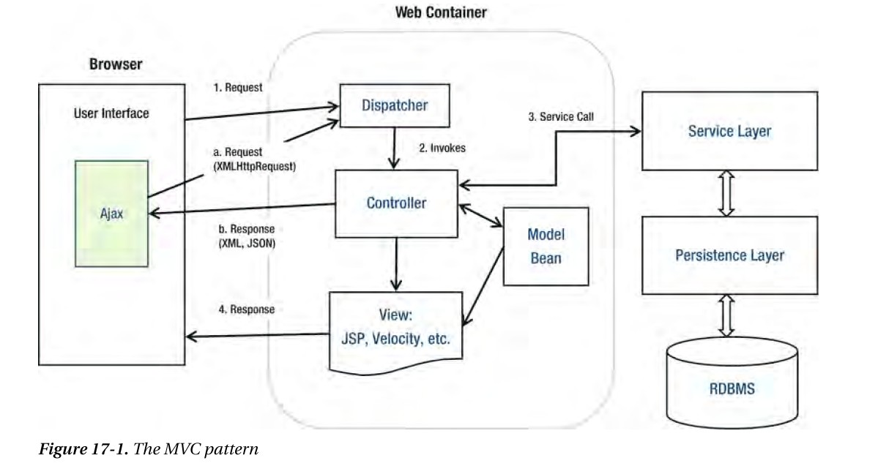

The illustration of how our system Spring Web MVC architecture works.

**Object-Oriented Architectural Style**

Object-oriented architecture is a design paradigm based on the division of responsibilities for an application or system into individual reusable and self-sufficient objects, each containing the data and the behavior relevant to the object. An object-oriented design views a system as a series of cooperating objects, instead of a set of routines or procedural instructions. Objects are discrete, independent, and loosely coupled; they communicate through interfaces, by calling methods or accessing properties in other objects, and by sending and receiving messages.

**The reason for the decision**:-Understandable. It maps the application more closely to the real world objects, making it more understandable. Reusable. It provides for reusability through polymorphism and abstraction.

**Benefits of using object-oriented architectural style**

Testable. It provides for improved testability through encapsulation. Extensible. Encapsulation, polymorphism, and abstraction ensure that a change in the representation of data does not affect the interfaces that the object exposes, which would limit the capability to communicate and interact with other objects. Highly Cohesive. By locating only related methods and features in an object, and using different objects for different sets of features, we can achieve a high level of cohesion.

**2.3. PHYSICAL ARRANGEMENTS OF DEVICES**

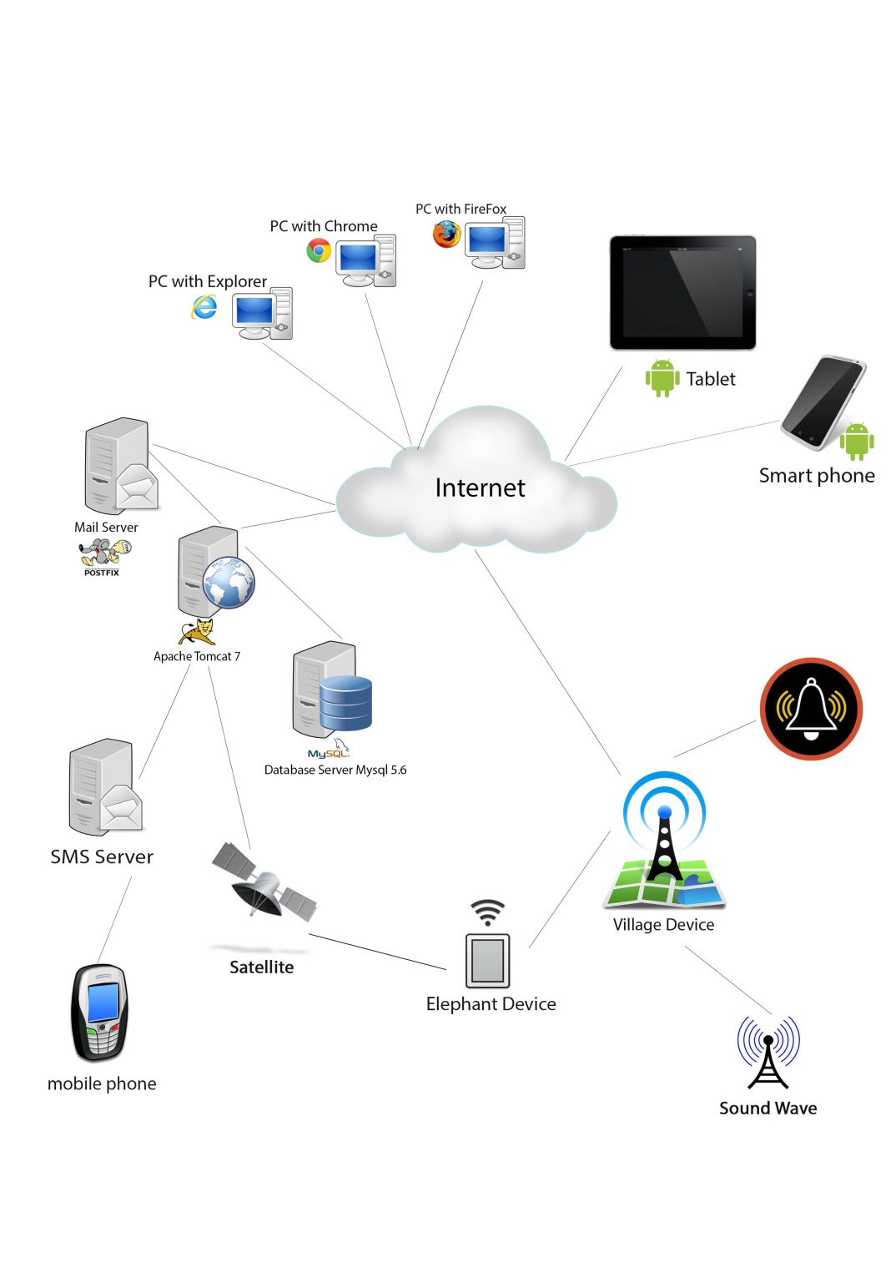

**2.4. DESIGN DECISIONS**

**2.4.1. Spring Web MVC development style is been used**

Reason: spring web MVC can be taken as for a popular and easy to handle web application development framework that has the feature of separating the Presentation, Business and Intermediate logics. So using the MVC style, it’ll ease the coding and provide well defined interfaces within every logic.

**2.4.2. Object Oriented Software development method is used**

Reason: - Since this system is used mostly within a specific set of users, we’re not expecting millions of hits in to the application within few milliseconds. Rather than we’re focusing on the extensibility of the system which will be really helpful for further developments according to requirements. So Object Oriented style is slightly behind from the perspective of performance, it’ll satisfy the main target described above.

**2.4.3. AJAX (Asynchronous JavaScript and XML) is used**

Reason: - AJAX allows web pages to be updated asynchronously by exchanging small amounts of data with the server behind the scenes. So it provides better interactivity to their users. This is due to the fact that implementing AJAX on a website does not require a page to be reloaded for dynamic content on web pages.

**3. COMPONENT AND DETAIL DESIGN**

**3.1. DESIGN PATTERNS**

**3.1.1. Prototype Pattern**

Declare an abstract base class that specifies a pure virtual “clone” method, and, maintains a dictionary of all “cloneable” concrete derived classes. Any class that needs a “polymorphic constructor” capability: derives itself from the abstract base class, registers its prototypical instance, and implements the clone() operation.

**Reason for using Prototype pattern:**

When applying access control list enforcements to the user, there will be an abstract model class that break in to two concrete model classes name ARO and ACO. These classes can get in to work by making clone() from the abstract model class.

**3.1.2. Observation Pattern**

Basically this pattern defines an object that is the “keeper” of the data model or business logic (the Subject). Delegate all “view” functionality to decoupled and distinct Observer objects. Observers register themselves with the Subject as they are created. Whenever the Subject changes, it broadcasts to all registered Observers that it has changed, and each Observer queries the Subject for that subset of the Subject’s state that it is responsible for monitoring.

**Reason for using Observer pattern:**

In our projects' MVC architectural pattern, The separation of Models and Views done through the decoupling method. So that enhance to ability of increasing flexibility and reusing of code in a way that it reduce the redundant coding. In that fact, we identified that it is very efficient to decouple objects so that changes to one can affect any number of others without requiring the changed object to know details of the others, simply This allows the number and “type” of “view” objects to be configured dynamically, instead of being statically specified.

**3.1.2. Composite Design Pattern**

The Composite is known as a structural pattern, as it's used to form large object structures across many disparate objects. This pattern allows us to set up a tree structure and ask each element in the tree structure to perform a task. After the tree structure is established, we can then ask each element, to perform a common operation.

**Reason for using Composite pattern:**

CakePHP has the native support of view elements that can be added separately in to a view which performs a specific view task. For an example we can have specifically implemented set of buttons under an “index” view, where we need navigation to different pages. It clearly specifies that the view “index” is nesting various types of button elements.

**3.1.2. Strategy Design Pattern**

This design pattern is very useful when n it comes to define a family of algorithms, encapsulate each one and make them interchangeable. It allows us to change the algorithm independently with out changing the client using it. It converts the generalization of the template method to composition or aggregation.

**Reason for using Strategy pattern:**

In our planned development in MVC pattern, the View-Controller relationship can be maintained by burying the complex algorithms inside the controllers and let the views to render only the content passed by the controllers. It’s useful when we want to replace the algorithm either statically or dynamically, when we have a lot of variants of the algorithm for example the filtering scenario of students using diffident algorithmic factors, or when the algorithm has complex data structures that we want to encapsulate.

**3.2. CLASS DIAGRAM**

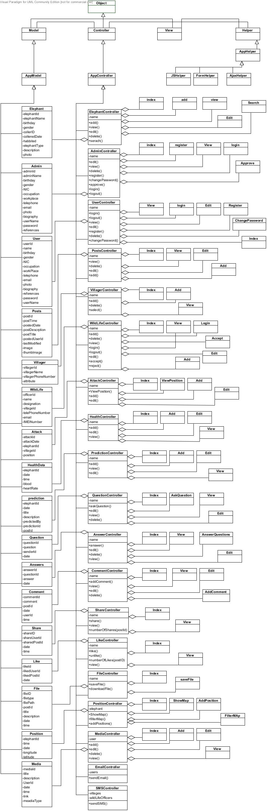

**3.3. SEQUENCE DIAGRAMS**

**3.3.1. HEC Sequence Diagrams**

1. Subscribe

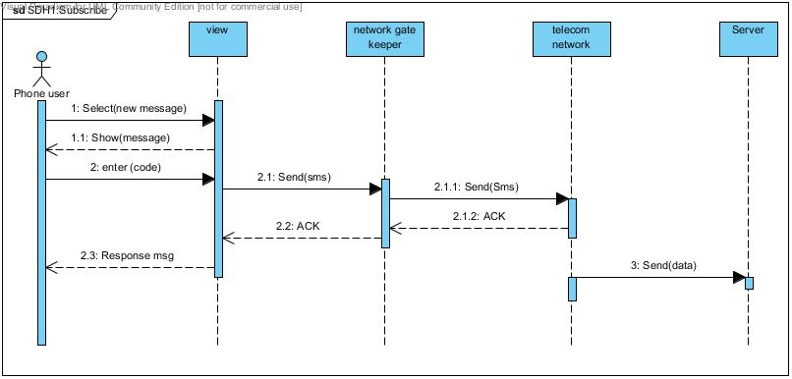

2. Register

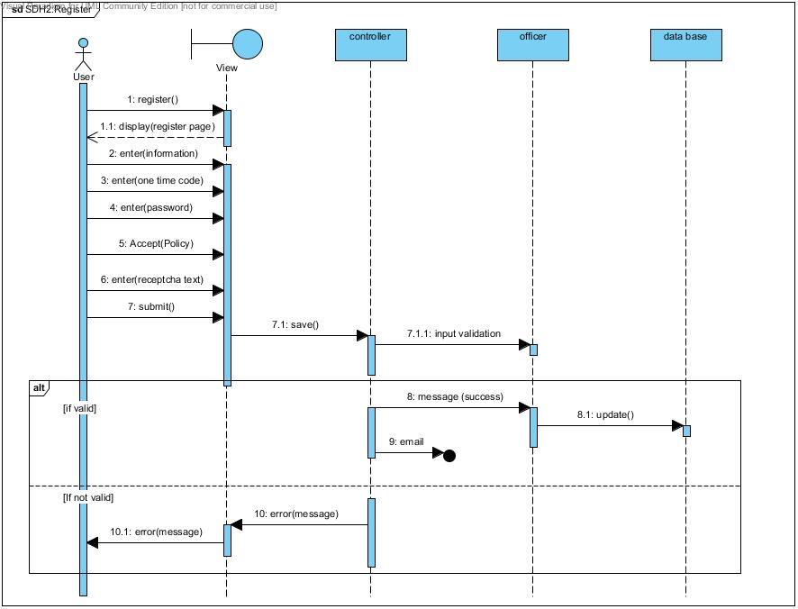

3. Send Push SMS

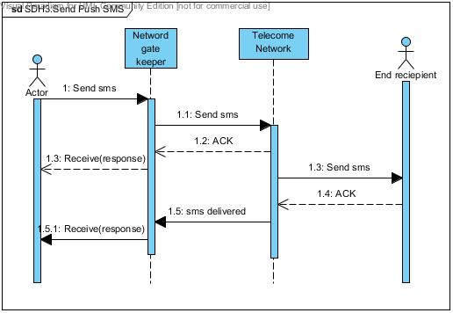

4. Detect Threat and Threat msg Processing

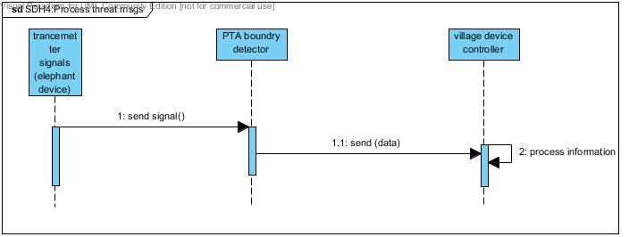

5. Send threat msgs to server

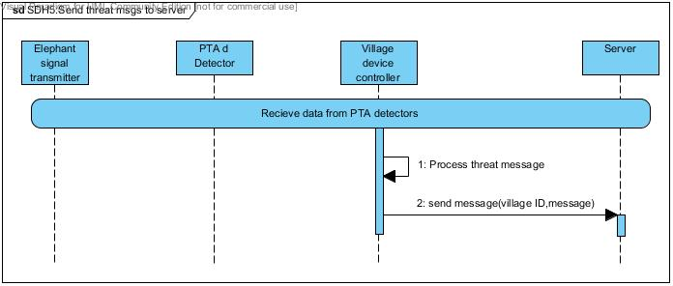

6. Start Ultra sound wave

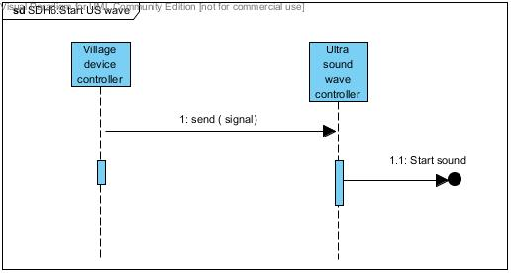

7. Stop Ultra sound wave

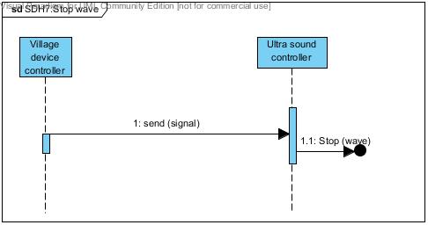

8. Receive data from safe zone detectors

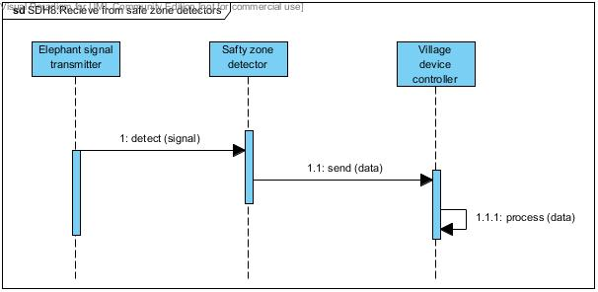

9. Process critical treat msgs

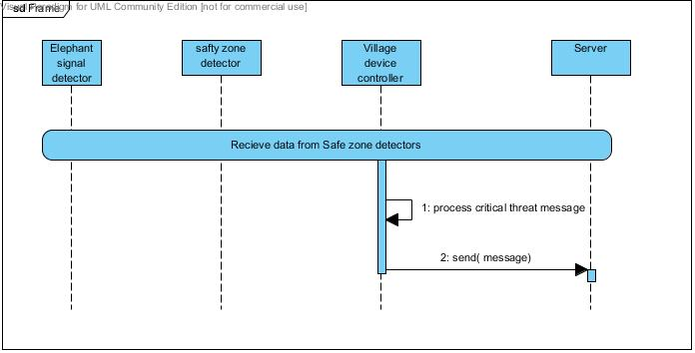

10. Start alarm

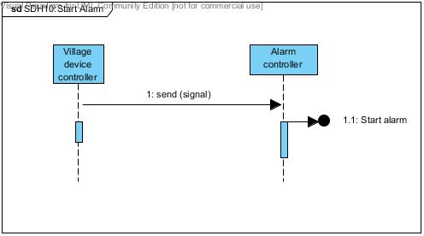

11. Stop alarm

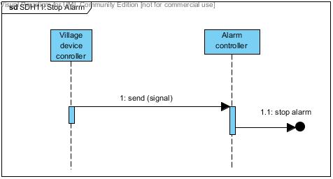

12. Notify Wild Life

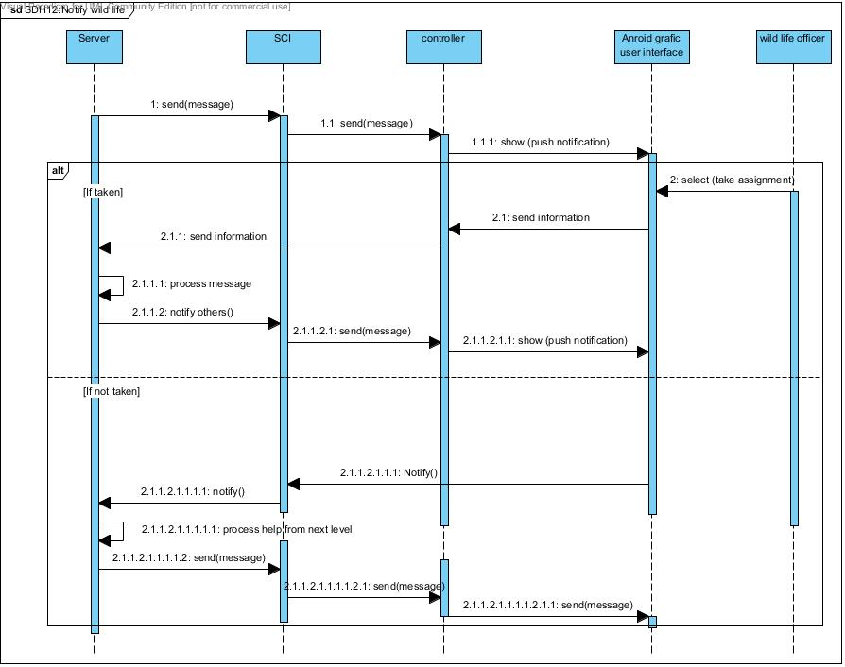

13. Ask backup

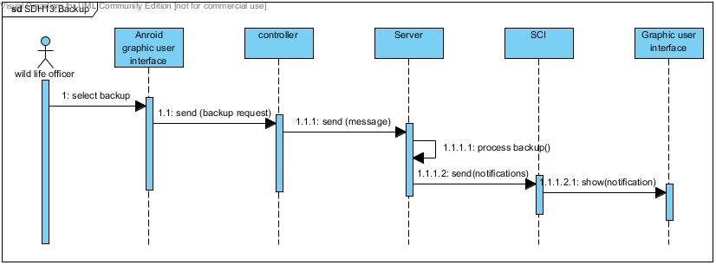

14. Ask for a doctor

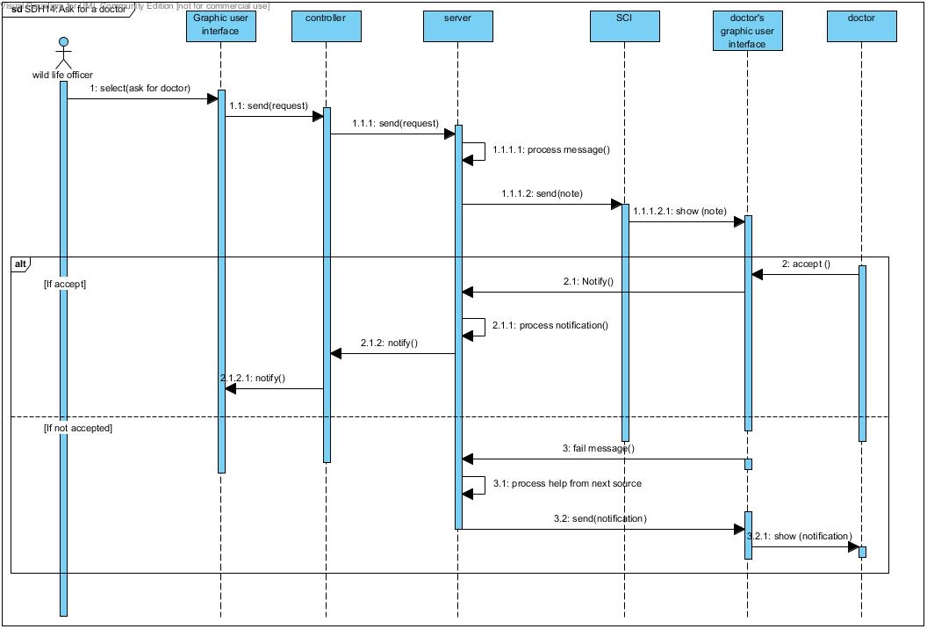

15. Take Assignment

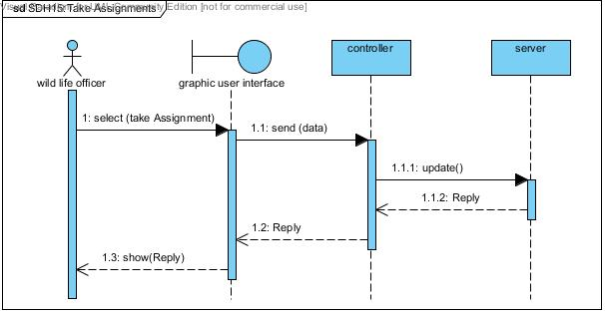

16. Compose Safety msgs

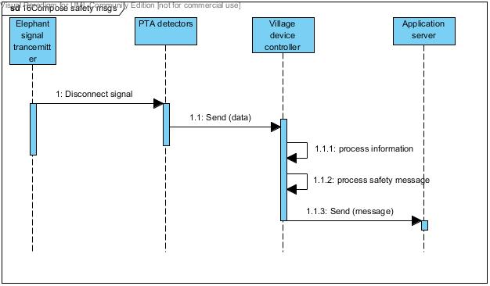

**3.3.1. Analyser Sequence Diagrams**

1.Add Elephant

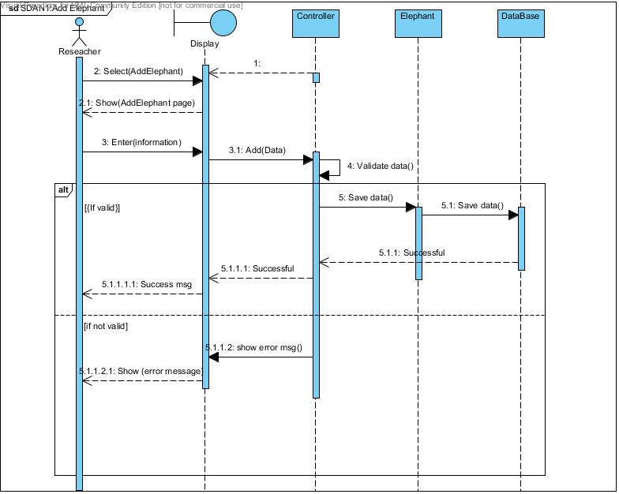

2. Generate Reports

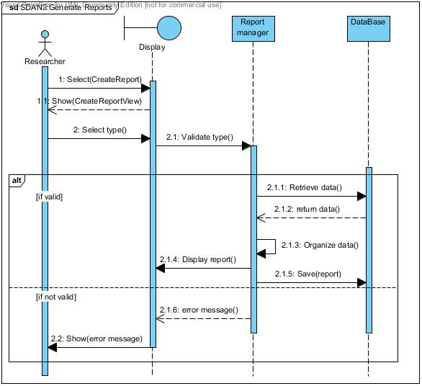

3. Print Reports

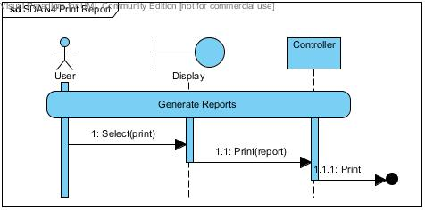

4. DownLoad Reports

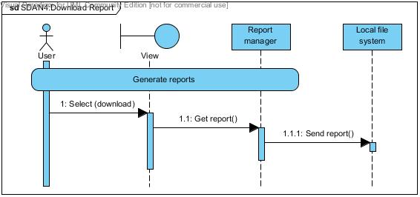

5. Edit elephant Details

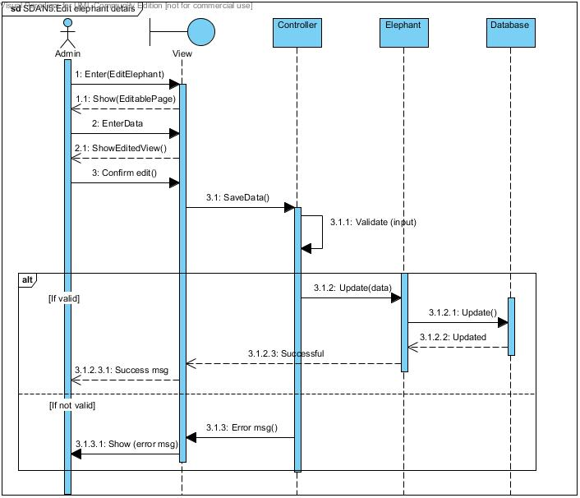

6. Create map

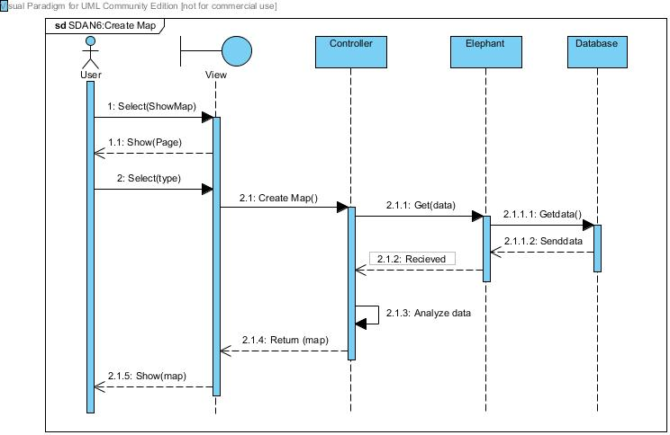

7. Position Update

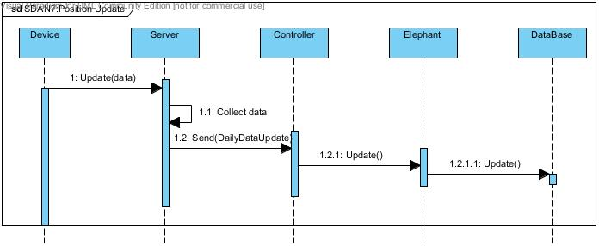

8. Health Data Update

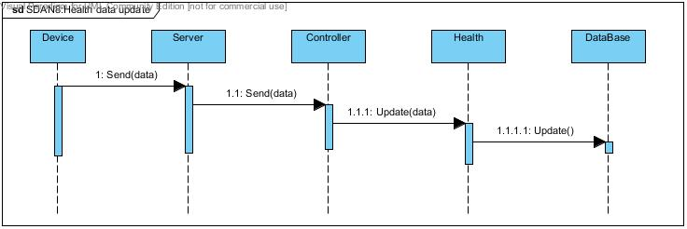

9. Generate health predictions

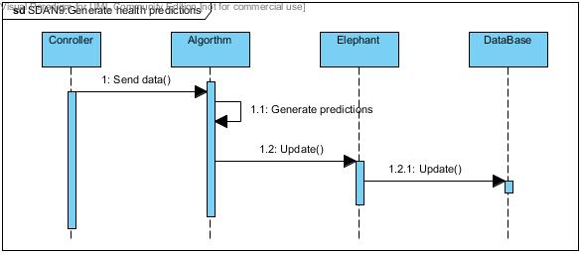

10. Generate health and safety alerts

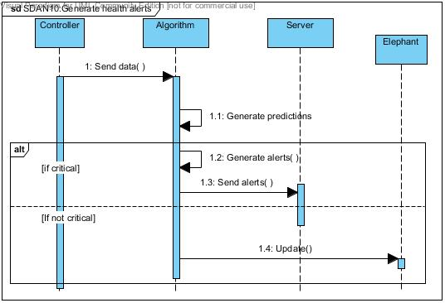

11. Show health data

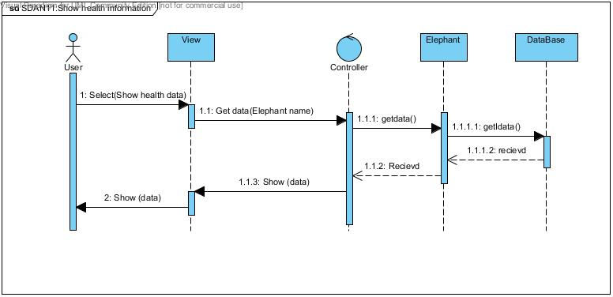

12. Show health information (Predictions)

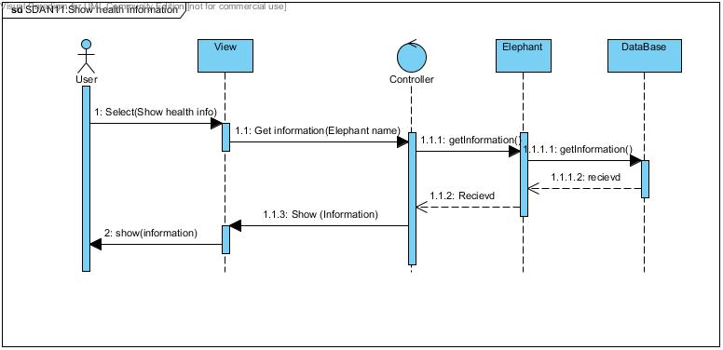

13. Auto show information on screen

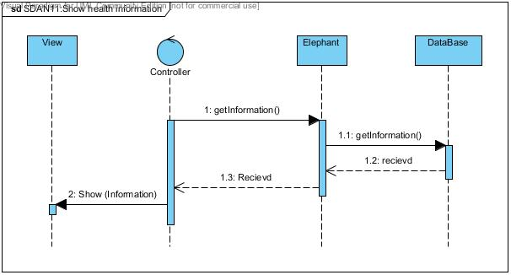

**3.3.1. WEB Sequence Diagrams**

1. Login

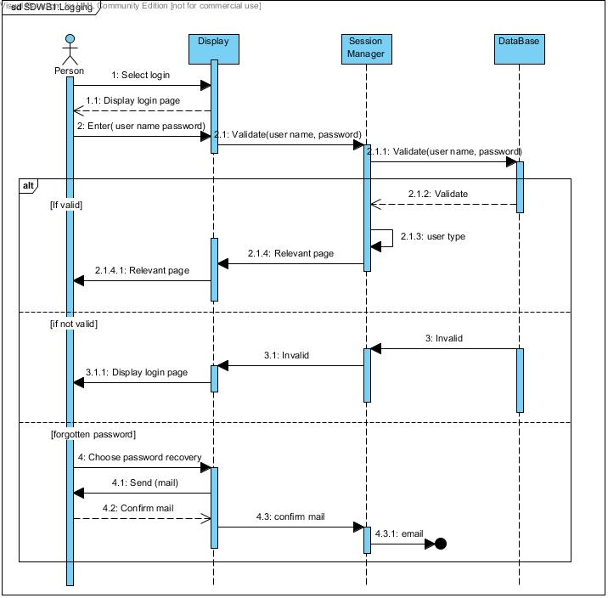

2. Register

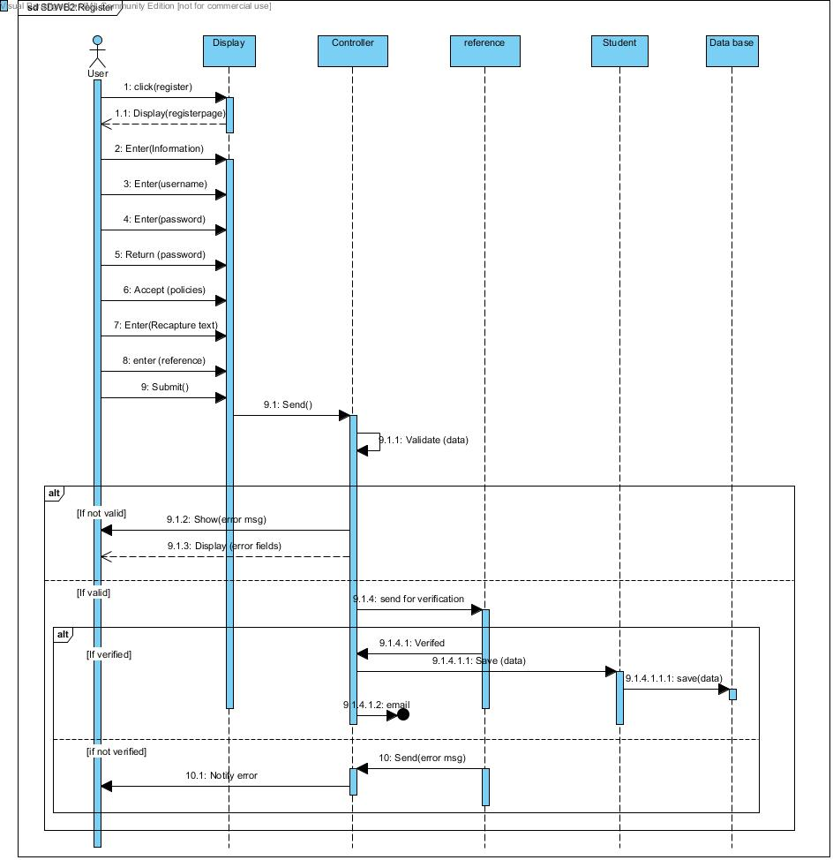

3. Edit user Profile

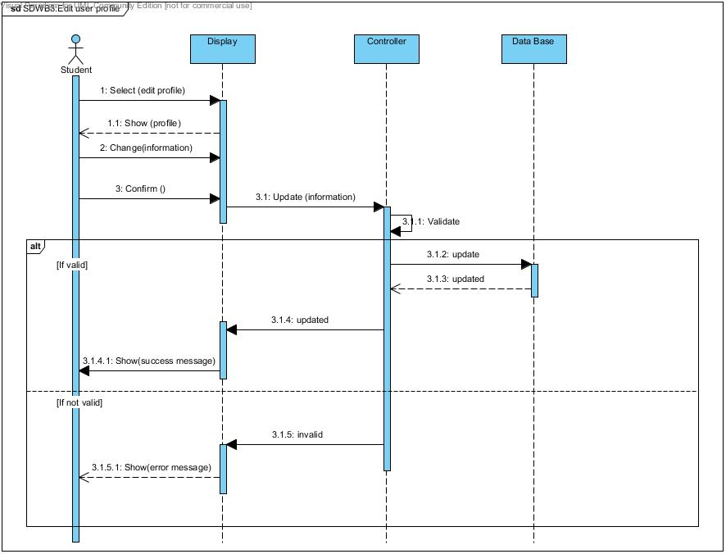

4. Change password

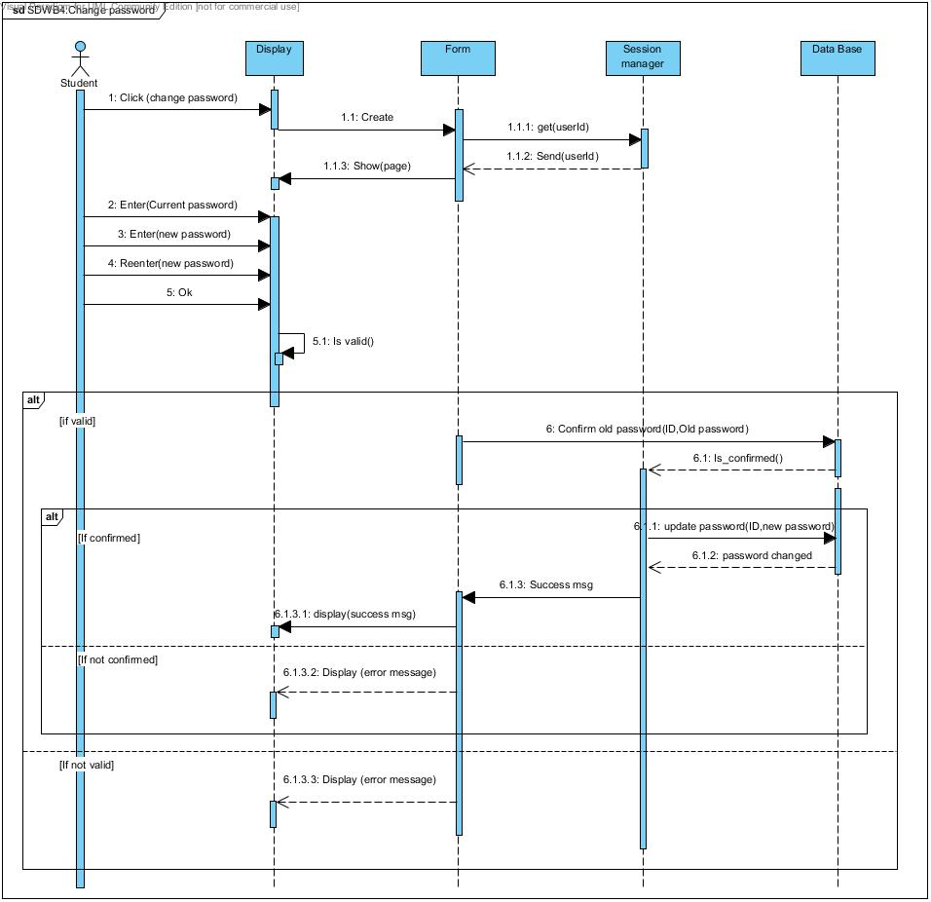

5. Comment

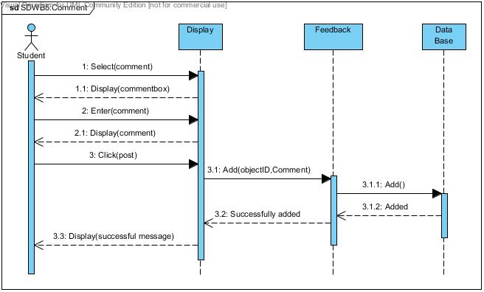

6. Remove comment

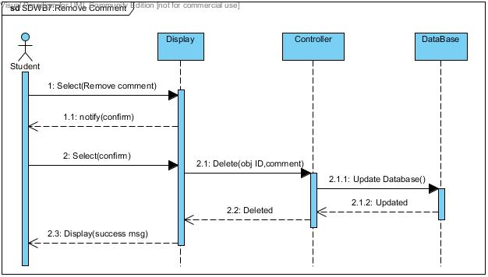

7. Edit comment

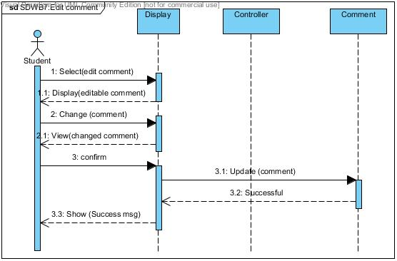

8. Add photo

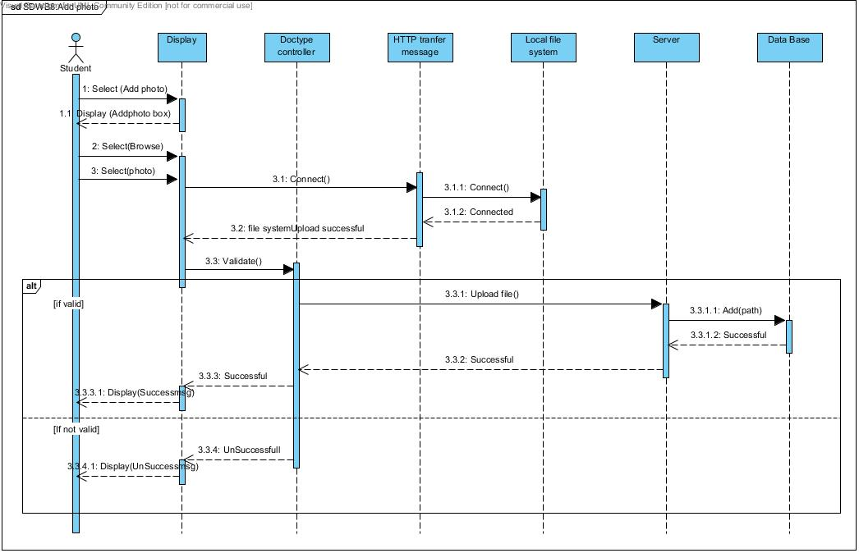

9. Remove photo

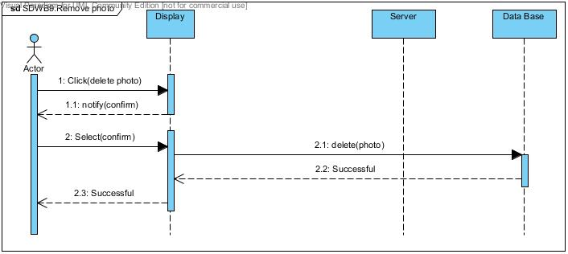

10. Add video

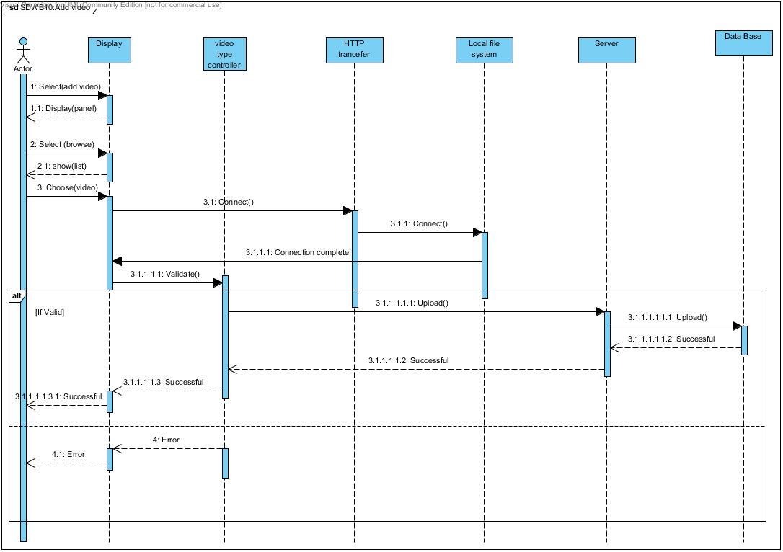

11. Delete video

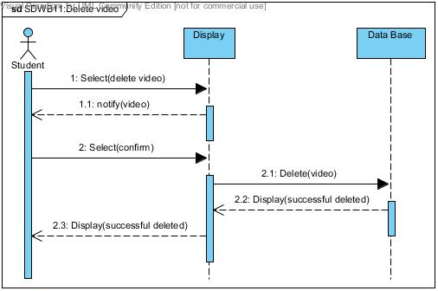

12. Add posts

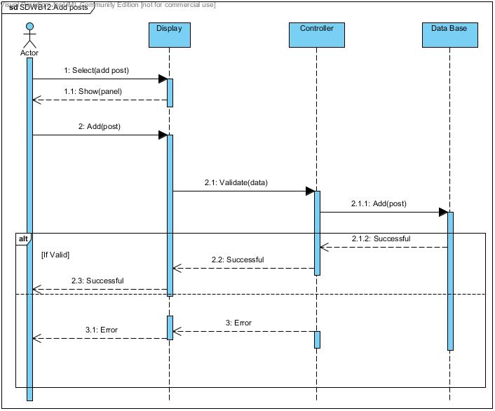

13. Edit posts

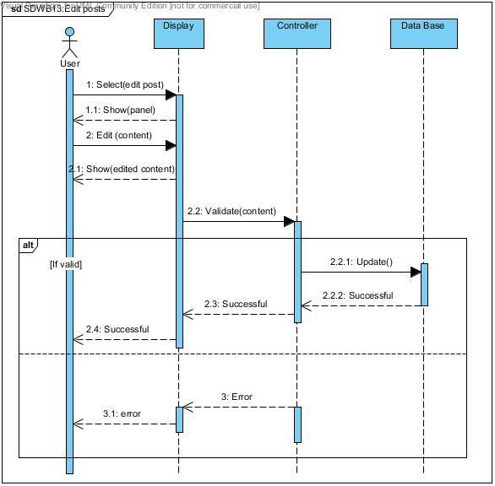

14. Delete posts

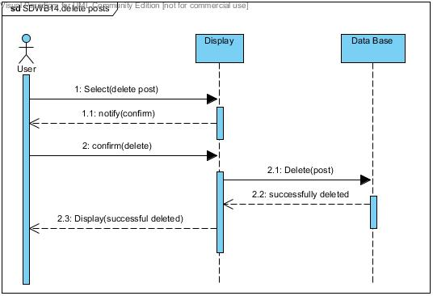

15. Upload docs

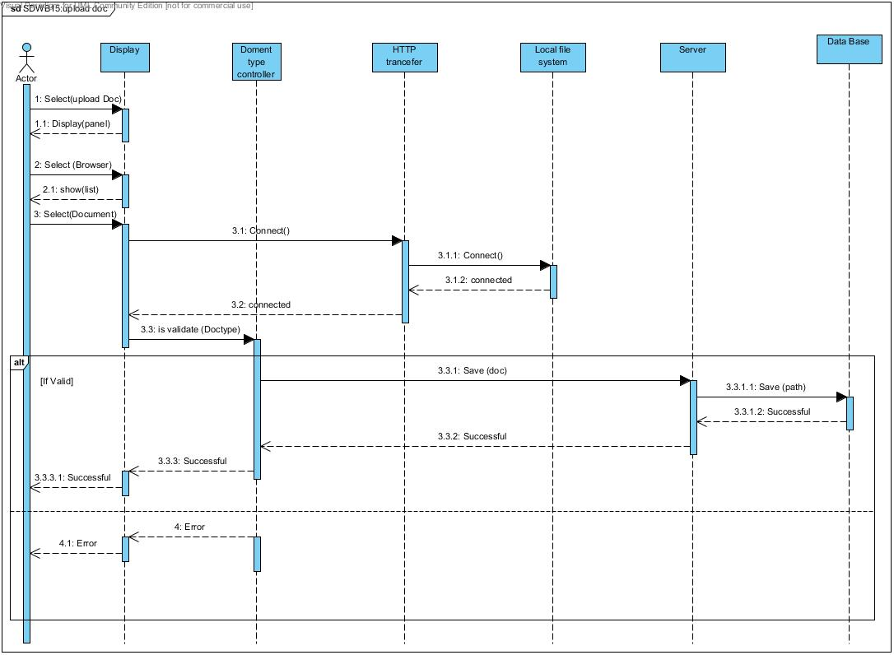

16. Delete docs

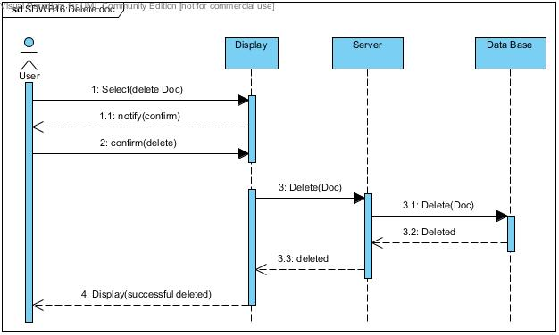

17. Ask Questions

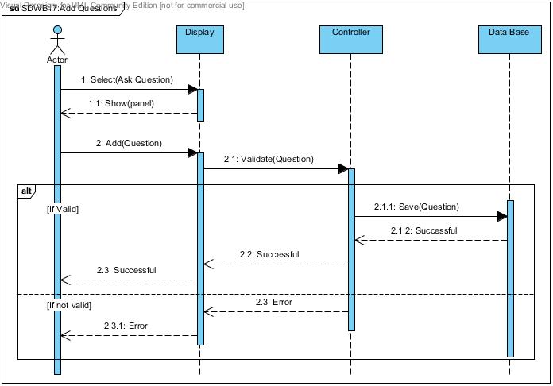

18. Delete Questions

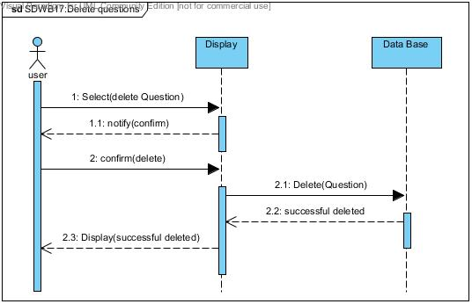

19. Edit Questions

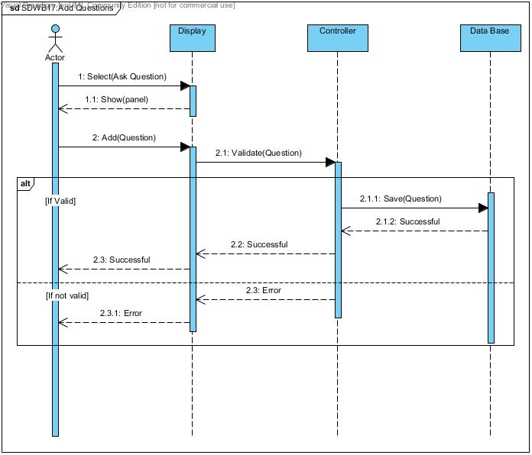

20. Answer Questions

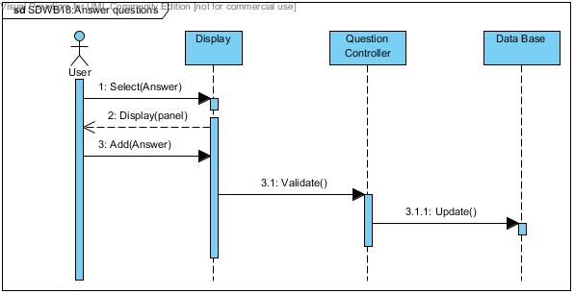

21. Edit Answer

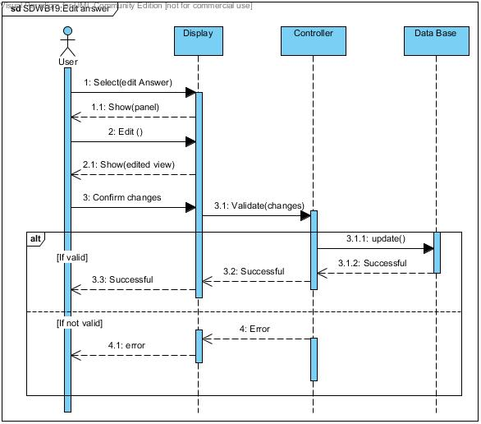

22. Download

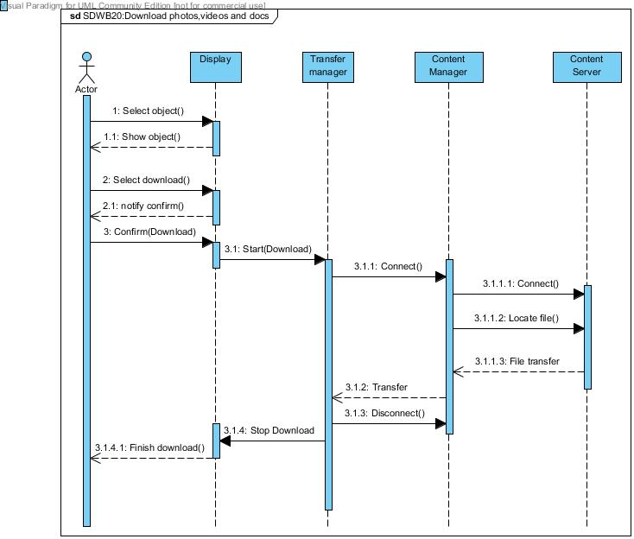

23. Remove user

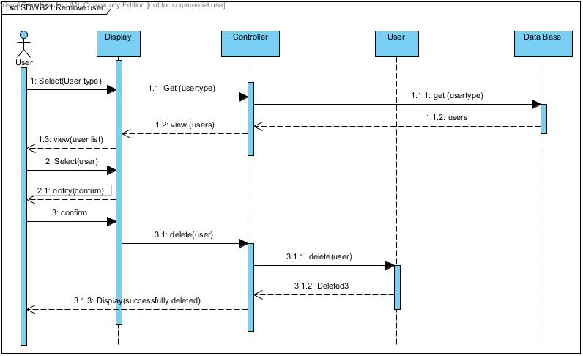

24. Add user

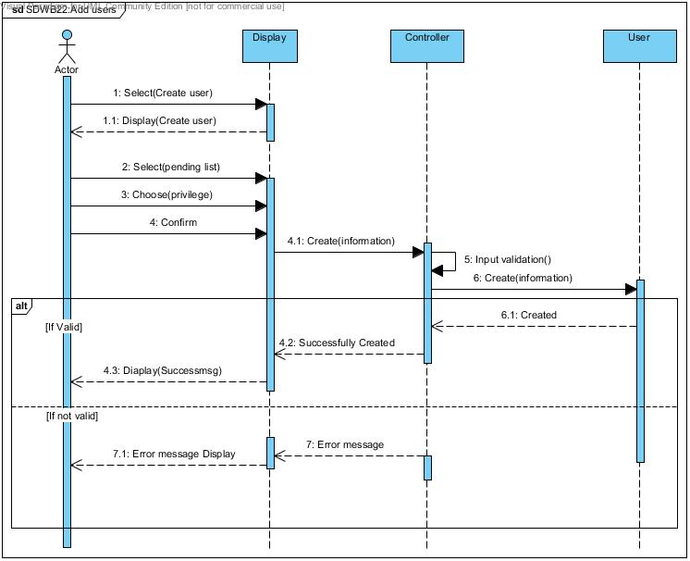

25. Change privileged levels by admin

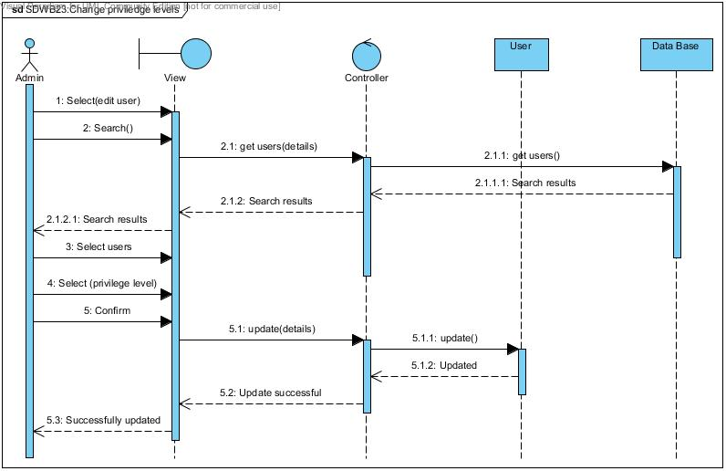

26. Remove posts by admin

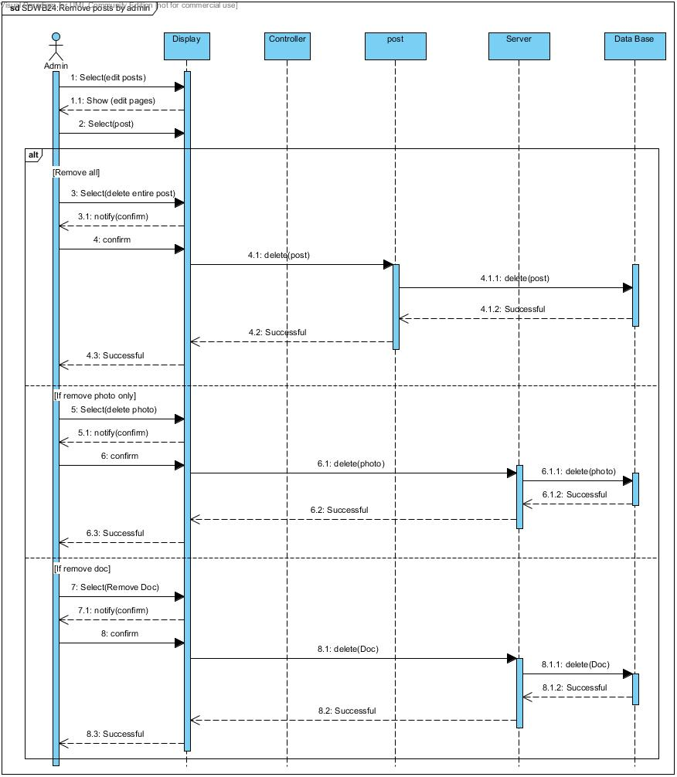

27. Edit comments by admin

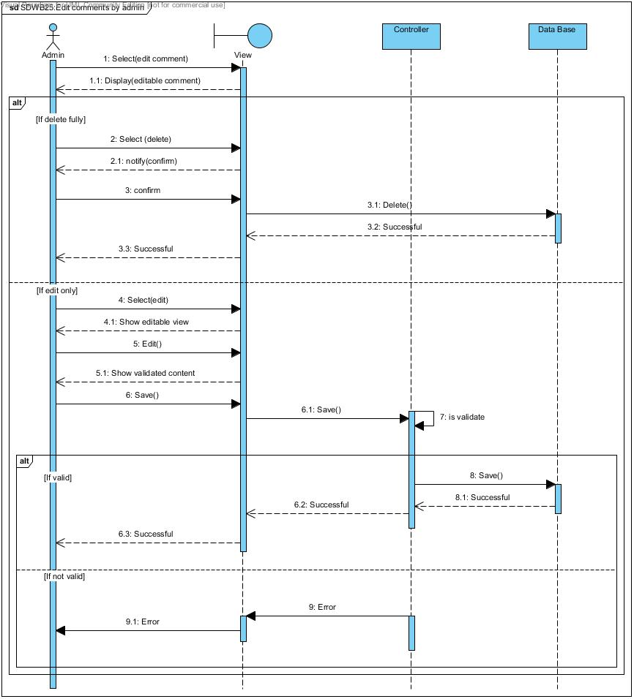

**3.3 ALGORITHM DESIGN**

3.3.1. Filter algorithm for Map Component

1. Load Filter View

2. Select Elephant name

3. Select map type

4. Select ‘Show map’

**Pseudo code**

Map_period array = calculate date range from map type

Do while map_period = NULL

If map period matches elephant

Return true

Else

Return false

End Do

3.3.2. HealthData Filter Algorithm

1. Load Filter View

2. Select elephant name

3. Select data type

4. select freaquency

**Pseudo code**

data array = calculate from data type and frequency

Do while data= NULL

If data matches elephant

Return true

Else

Return false

End Do

**3.4 DATABASE DESIGN**

**3.4.1 Relational Model**

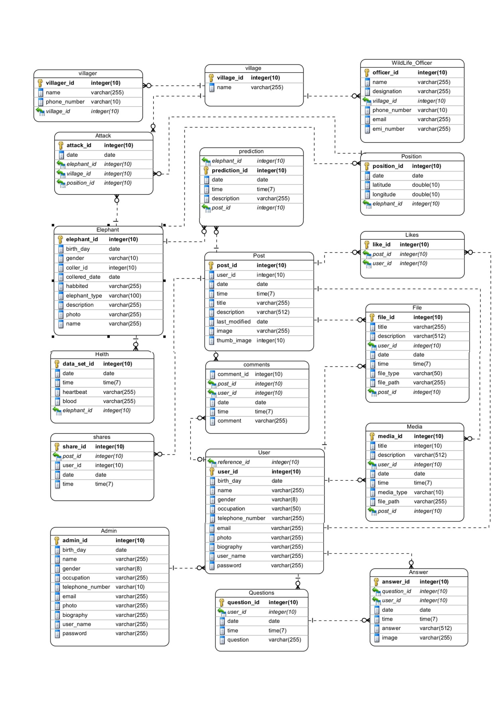

**3.4.2 Normalization/ Denormalization**

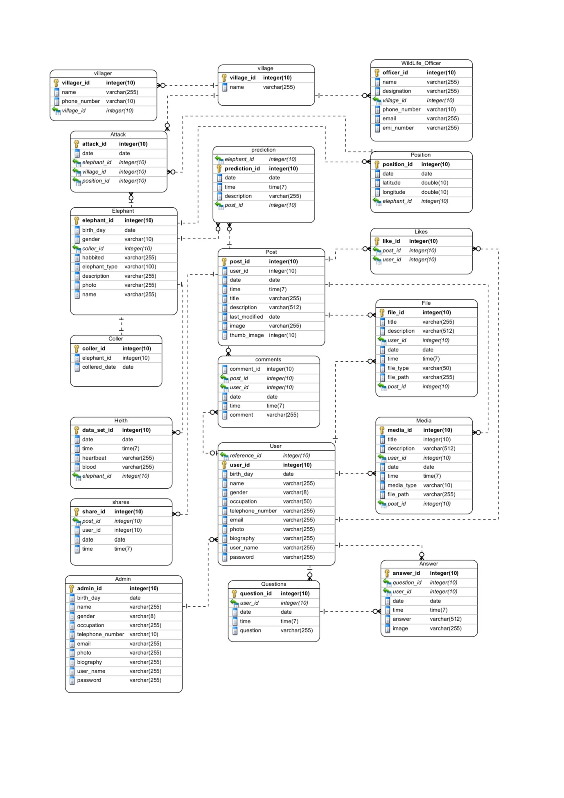

**3.4.3 Data Dictionary**

|  |  |  |  |
| --- | --- | --- | --- |
| Villager | | | |
| **Field** | **Data type** | **Null** | **Description** |
| **Villager_id** | **Integer(10)** | No |  |
| name | Varchar(255) | No |  |
| Phone_number | Varchar(10) | No |  |
| Village_id | Integer(10) | No |  |

|  |  |  |  |
| --- | --- | --- | --- |
| Attack | | | |
| **Field** | **Data type** | **Null** | **Description** |
| **Attack_id** | **Integer(10)** | No |  |
| date | Date | No |  |
| elephant_id | Integer(10) | No |  |
| village_id | Integer(10) | No |  |
| Position_id | Integer(10) | No |  |

|  |  |  |  |
| --- | --- | --- | --- |
| Elephant | | | |
| **Field** | **Data type** | **Null** | **Description** |
| **elephant_id** | **Integer(10)** | No |  |
| birth_day | Date | Yes |  |
| gender | Varchar(10) | Yes |  |
| coller_id | Integer(10) | Yes |  |
| collered_date | Date | Yes |  |
| habited | Varchar(255) | Yes |  |
| elephant_type | Varchar(100) | No |  |
| description | Varchar(255) | Yes |  |
| photo | Varchar(255) | Yes |  |

|  |  |  |  |
| --- | --- | --- | --- |
| Health | | | |
| **Field** | **Data type** | **Null** | **Description** |
| **data_set_id** | **Integer(10)** | No |  |
| date | Date | No |  |
| time | Time(7) | No |  |
| heartbeat | Varchar(255) | Yes |  |
| blood | Varchar(255) | Yes |  |
| elephant**_**id | Integer(10) | No |  |

|  |  |  |  |
| --- | --- | --- | --- |
| Admin | | | |
| **Field** | **Data type** | **Null** | **Description** |
| **admin_id** | **Integer(10)** | No |  |
| birthday | Date | Yes |  |
| name | Varchar(255) | No |  |
| gender | Varchar(8) | No |  |
| occupation | Varchar(255) | Yes |  |
| telephone_number | Integer(10) | Yes |  |
| email | Varchar(255) | No |  |
| photo | Varchar(255) | Yes |  |
| biography | Varchar(255) | Yes |  |
| user_name | Varchar(255) | No |  |
| password | Varchar(255) | No |  |

|  |  |  |  |
| --- | --- | --- | --- |
| Village | | | |
| **Field** | **Data type** | **Null** | **Description** |
| **village_id** | **Integer(10)** | No |  |
| name | Varchar(255) | No |  |

|  |  |  |  |
| --- | --- | --- | --- |
| Prediction | | | |
| **Field** | **Data type** | **Null** | **Description** |
| elephant_id | Integer(10) | No |  |
| prediction_id | **Integer(10)** | No |  |
| date | Date | No |  |
| time | Time(7) | No |  |
| description | Varchar(255) | Yes |  |
| post_id | Integer(10) | Yes |  |

|  |  |  |  |
| --- | --- | --- | --- |
| Post | | | |
| **Field** | **Data type** | **Null** | **Description** |
| **post_id** | **Integer(10)** | No |  |
| user_id | Integer(10) | No |  |
| date | Date | No |  |
| time | Time(7) | No |  |
| title | Varchar(255) | Yes |  |
| description | Varchar(512) | Yes |  |
| last_modified | Date | Yes |  |
| image | Varchar(255) | Yes |  |
| thumb_image | Integer(10) | Yes |  |

|  |  |  |  |
| --- | --- | --- | --- |
| Comments | | | |
| **Field** | **Data type** | **Null** | **Description** |
| comment_id | Integer(10) | No |  |
| post_id | Integer(10) | No |  |
| user_id | Integer(10) | No |  |
| date | Date | No |  |
| time | Time(7) | NO |  |
| comment | Varchar(255) | No |  |

|  |  |  |  |
| --- | --- | --- | --- |
| User | | | |
| **Field** | **Data type** | **Null** | **Description** |
| reference_id | Integer(10) | No |  |
| **user_id** | **Integer(10)** | No |  |
| birth_day | Date | No |  |
| name | Varchar(255) | No |  |
| gender | Varchar(8) | No |  |
| occupation | Varchar(50) | Yes |  |
| telephone_number | Varchar(255) | Yes |  |
| email | Varchar(255) | NO |  |
| photo | Varchar(255) | Yes |  |
| biography | Varchar(255) | Yes |  |
| user_name | Varchar(255) | No |  |
| password | Varchar(255) | No |  |

|  |  |  |  |
| --- | --- | --- | --- |
| Questions | | | |
| **Field** | **Data type** | **Null** | **Description** |
| **question_id** | **Integer(10)** | NO |  |
| user_id | Integer(10) | No |  |
| date | Date | No |  |
| time | Time(7) | No |  |
| question | Varchar(255) | NO |  |

|  |  |  |  |
| --- | --- | --- | --- |
| Wildlife officer | | | |
| **Field** | **Data type** | **Null** | **Description** |
| **Officer_id** | **Integer(10)** | No |  |
| name | Varchar(255) | No |  |
| designation | Varchar(255) | No |  |
| village_id | Integer(10) | NO |  |
| phone_number | Varchar(10) | Yes |  |
| email | Varchar(255) | No |  |
| emi_number | Varchar(255) | No |  |

|  |  |  |  |
| --- | --- | --- | --- |
| Position | | | |
| **Field** | **Data type** | **Null** | **Description** |
| **position_id** | **Integer(10)** | No |  |
| date | Date | No |  |
| latitude | Double(10) | No |  |
| longitude | Double(10) | No |  |
| elephant_id | Integer(10) | No |  |

|  |  |  |  |
| --- | --- | --- | --- |
| Likes | | | |
| **Field** | **Data type** | **Null** | **Description** |
| **like_id** | **Integer(10)** | No |  |
| post_id | Integer(10) | No |  |
| user_id | Integer(10) | No |  |

|  |  |  |  |
| --- | --- | --- | --- |
| File | | | |
| **Field** | **Data type** | **Null** | **Description** |
| **file_id** | **Integer(10)** | No |  |
| title | Varchar(255) | Yes |  |
| description | Varchar(512) | Yes |  |
| user_id | Integer(10) | No |  |
| date | Date | No |  |
| time | Time(7) | No |  |
| file_type | Varchar(50) | No |  |
| file_path | Varchar(255) | No |  |
| post_id | Integer(10) | No |  |

|  |  |  |  |
| --- | --- | --- | --- |
| Media | | | |
| **Field** | **Data type** | **Null** | **Description** |
| **media_id** | **Integer(10)** | No |  |
| title | Integer(10) | Yes |  |
| description | Varchar(512) | Yes |  |
| user_id | Integer(10) | No |  |
| date | Date | No |  |
| time | Time(7) | No |  |
| media_type | Varchar(10) | No |  |
| file_path | Varchar(255) | No |  |
| post_id | Integer(10) | No |  |

|  |  |  |  |
| --- | --- | --- | --- |
| Answer | | | |
| **Field** | **Data type** | **Null** | **Description** |
| **answer_id** | **Integer(10)** | No |  |
| question_id | Integer(10) | No |  |
| user_id | Integer(10) | No |  |
| date | Date | No |  |
| time | Time(7) | No |  |
| answer | Varchar(512) | No |  |
| image | Varchar(255) | Yes |  |

**3.4.4. Indexes**

Villager

|  |  |  |  |
| --- | --- | --- | --- |
| Keyname | Type | Unique | Column |
| Primary | BTREE | Yes | Villager_ID |
| NAME | BTREE | No | name |

Village

|  |  |  |  |
| --- | --- | --- | --- |
| Keyname | Type | Unique | Column |
| Primary | BTREE | Yes |  |
| NAME | BTREE | No |  |

|  |  |  |  |
| --- | --- | --- | --- |
| Attack | | | |
| KeyName | Type | Unique | Column |
| PRIMARY | BTREE | yes | attack_id |
| E_ID | BTREE | yes | elephant_id |

|  |  |  |  |
| --- | --- | --- | --- |
| Prediction | | | |
| KeyName | Type | Unique | Column |
| PRIMARY | BTREE | yes | prediction_id |
| E_ID | BTREE | yes | elephant_id |

|  |  |  |  |
| --- | --- | --- | --- |
| WildLife | | | |
| KeyName | Type | Unique | Column |
| PRIMARY | BTREE | yes | officer_id |
| NAME | BTREE | No | name |
| T_PHONE | BTREE | Yes | phone_number |
| EMAIL | BTREE | Yes | email |
| EMI_NUMBER | BTREE | Yes | emi_number |

|  |  |  |  |
| --- | --- | --- | --- |
| Post | | | |
| KeyName | Type | Unique | Column |
| PRIMARY | BTREE | yes | post_id |
| AUTHER | BTREE | yes | user_id |

|  |  |  |  |
| --- | --- | --- | --- |
| Like | | | |
| KeyName | Type | Unique | Column |
| PRIMARY | BTREE | yes | like_id |
| AUTHER | BTREE | yes | user_id |

|  |  |  |  |
| --- | --- | --- | --- |
| Comment | | | |
| KeyName | Type | Unique | Column |
| PRIMARY | BTREE | yes | comment_id |
| AUTHER | BTREE | yes | user_id |

|  |  |  |  |
| --- | --- | --- | --- |
| File | | | |
| KeyName | Type | Unique | Column |
| PRIMARY | BTREE | yes | file_id |
| AUTHER | BTREE | yes | user_id |

|  |  |  |  |
| --- | --- | --- | --- |
| Share | | | |
| KeyName | Type | Unique | Column |
| PRIMARY | BTREE | yes | share_id |
| AUTHER | BTREE | yes | user_id |

|  |  |  |  |
| --- | --- | --- | --- |
| User | | | |
| KeyName | Type | Unique | Column |
| PRIMARY | BTREE | yes | user_id |
| NAME | BTREE | No | name |
| T_NUMBER | BTREE | Yes | phone_number |
| EMAIL | BTREE | Yes | email |
| USER_NAME | BTREE | Yes | user_name |

|  |  |  |  |
| --- | --- | --- | --- |
| Admin | | | |
| KeyName | Type | Unique | Column |
| PRIMARY | BTREE | yes | admin_id |
| NAME | BTREE | No | name |
| T_NUMBER | BTREE | Yes | phone_number |
| EMAIL | BTREE | Yes | email |
| USER_NAME | BTREE | Yes | user_name |

|  |  |  |  |
| --- | --- | --- | --- |
| Question | | | |
| KeyName | Type | Unique | Column |
| PRIMARY | BTREE | yes | question_id |
| AUTHER | BTREE | yes | user_id |

|  |  |  |  |
| --- | --- | --- | --- |
| Answer | | | |
| KeyName | Type | Unique | Column |
| PRIMARY | BTREE | yes | answer_id |
| Q_ID | BTREE | yes | question_id |
| AUTHER | BTREE | yes | user_id |

|  |  |  |  |
| --- | --- | --- | --- |
| Media | | | |
| KeyName | Type | Unique | Column |
| PRIMARY | BTREE | yes | media_id |
| AUTHER | BTREE | yes | user_id |

|  |  |  |  |
| --- | --- | --- | --- |
| Position | | | |
| KeyName | Type | Unique | Column |
| PRIMARY | BTREE | yes | position_id |
| E_ID | BTREE | yes | user_id |
| C_ID | BTREE | yes | coller_id |
| NAME | BTREE | No | name |

**3.5. USER INTERFACES**

**3.6. RULES AND GUIDELINES FOR INTERFACE DESIGN**

**3.6.1 User interface design framework**

This Project we use Bootstrap for front view to get responsive (http://getbootstrap.com/) for Web interfaces.

**Reason: -** This framework is very much helpful for a clean and professional design. Since this is a very popular framework and developed by a reputed company, framework documentation is well formed and there are many places that we can get help.

**3.6.2 User Input validation methods**

Basically this system will do all the form and data validation in the Model level. Given below is an illustration for the basic form validation process via Model.

**Reason: -** The Spring framework runs on top of an Active Record design pattern to connect with the database. So that feature enables us to have this kind of validation architecture which is more secure and readable.

**3.6.3 Alert messages decomposition**

We’ll be using following type of alert scheme for all over the system. So that people who are using this system will identify the type of the message just using the color of it.

**3.7. USER INTERFACES DESIGN**

3.7.1. HEC part

1. Subscribe

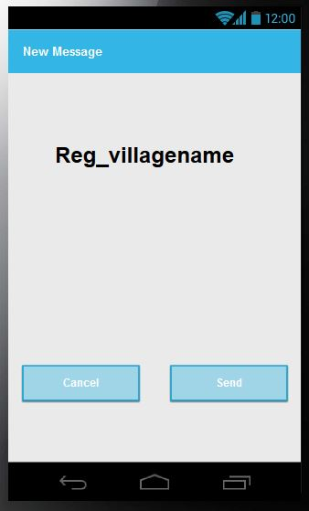

2. Register

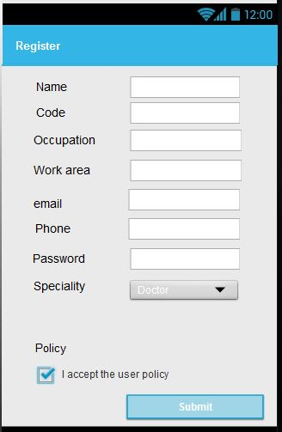

13. Ask for Backup

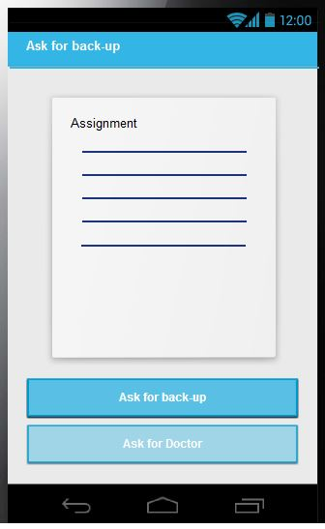

14. Ask for a Doctor



15. Take assignment

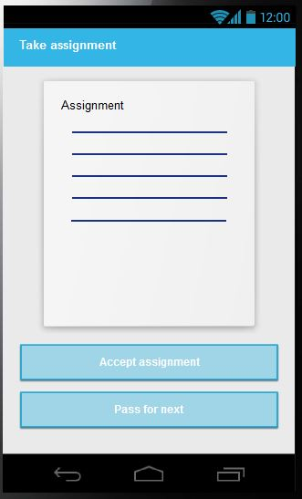

3.7.2. Analyzer

1. Add Elephant

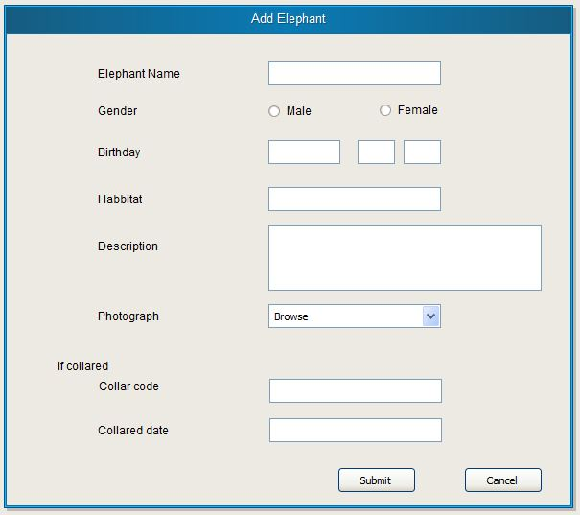

2. Generate reports

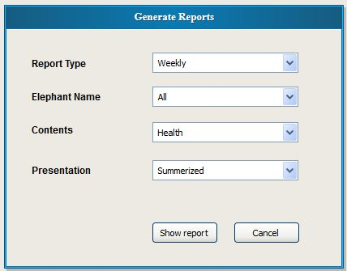

3. Print reports

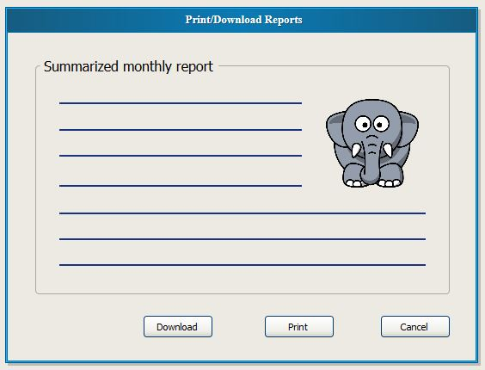

4. Download reports



5. Edit elephant Details

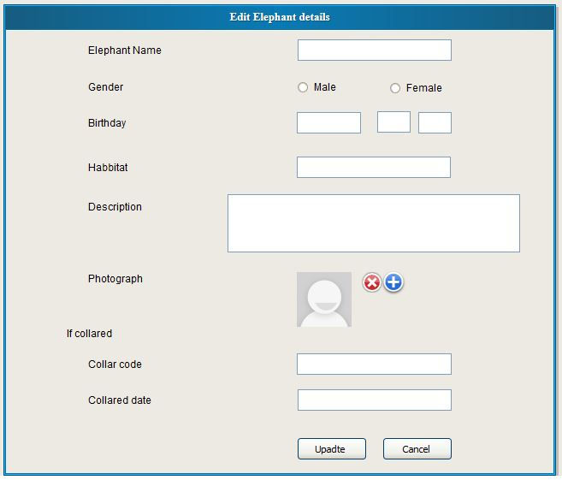

6. Show map

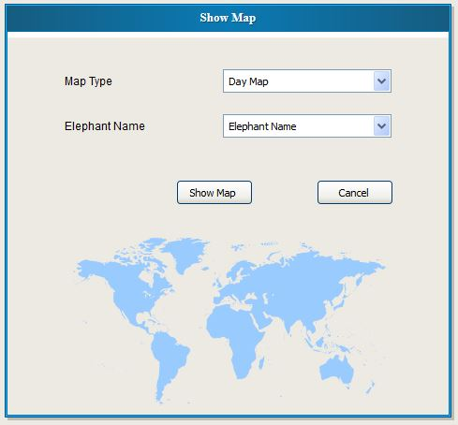

7. Position Update

8. Health data update

9. Generate health predictions

10. Generate health and safety alerts

11. Show health data

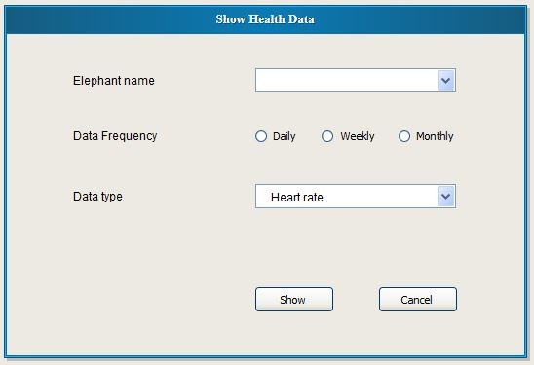

12. Show health information (Predictions)

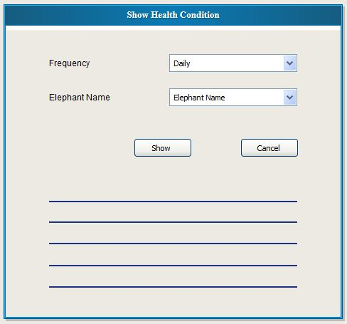

13. Auto show information on screen

3.7.3. Web part

1. Login

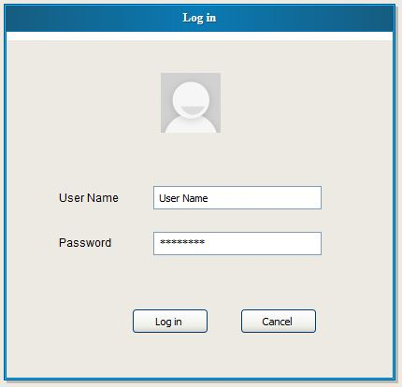

2. Register

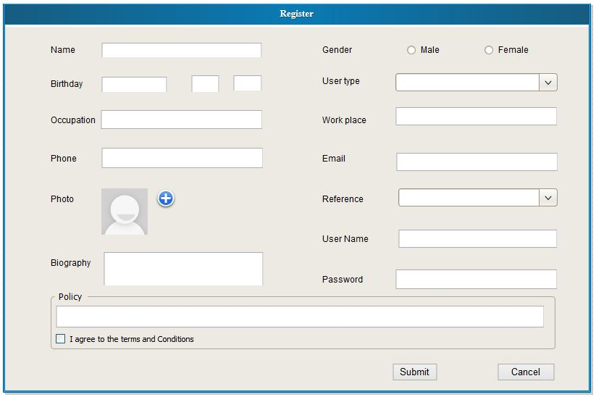

3. Edit User Profile

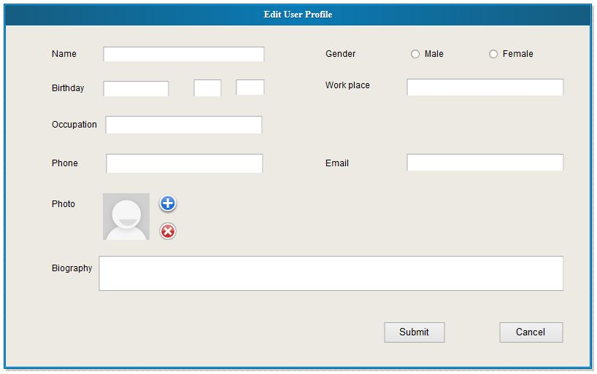

4. Change password

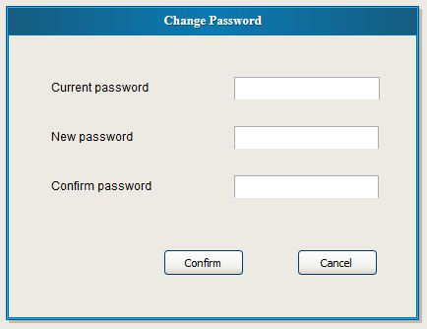

5. Comment

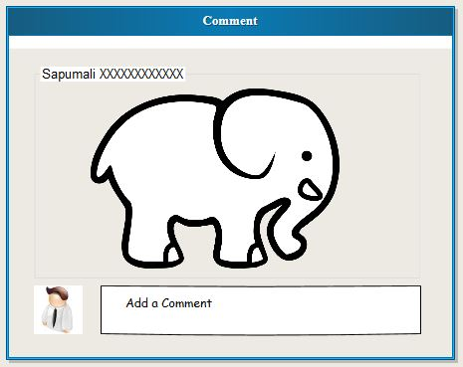

6. Remove Comment

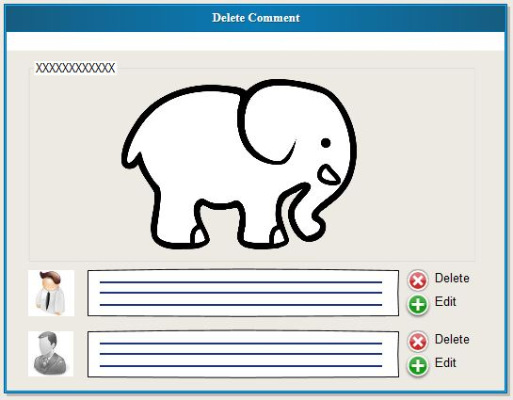

7. Edit Comment



8. Add photo

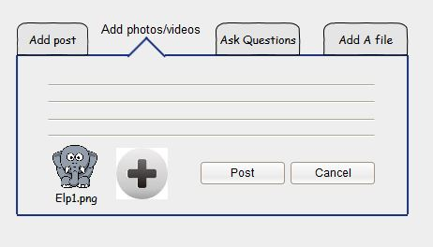

9. Remove photo

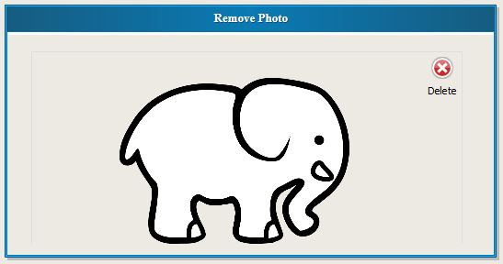

10. Add Video

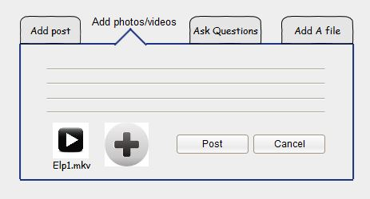

11. Remove video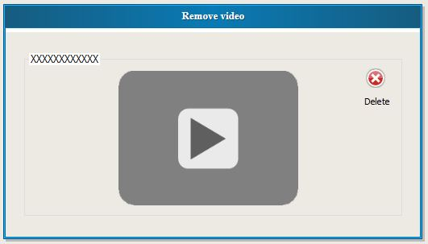

12. Add posts

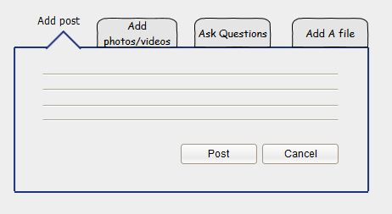

13. Edit posts

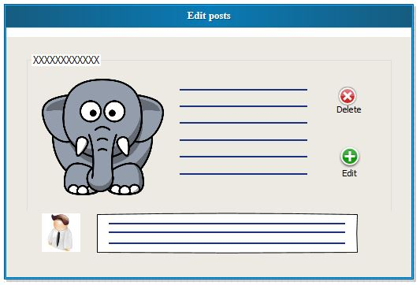

14. Delete Posts

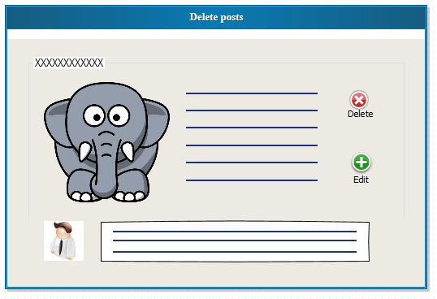

15. Upload Document

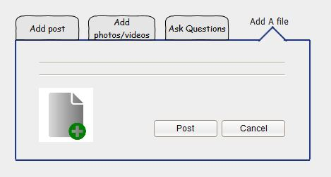

16. Delete Document

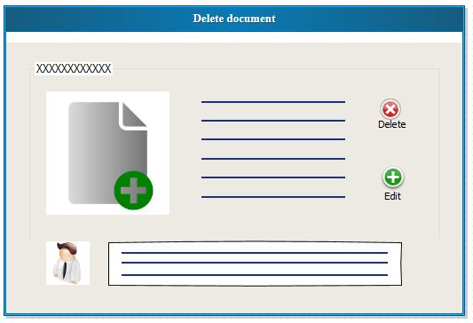

17. Ask Questions

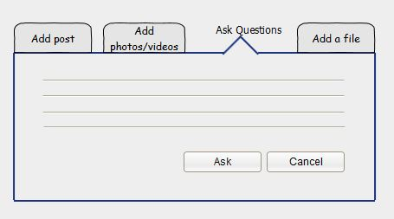

18. Delete Questions

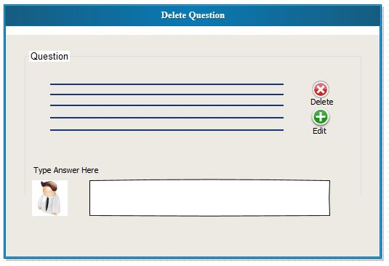

19. Edit Questions

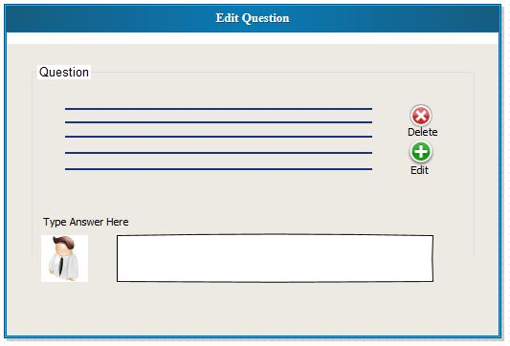

20. Answer Questions

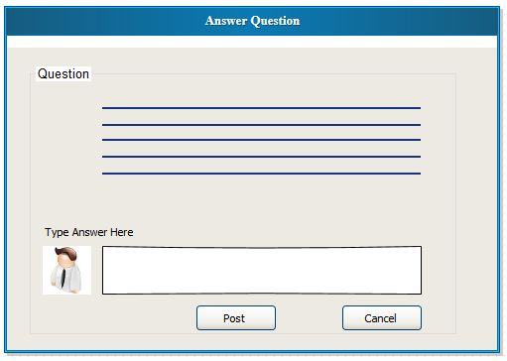

21. Edit Answer

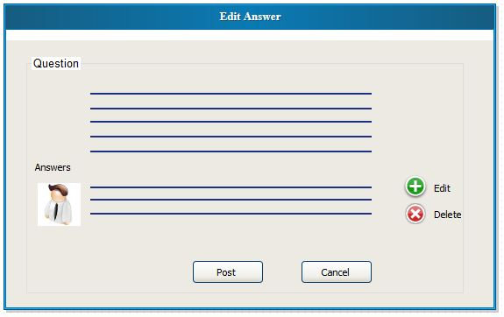

22. Download

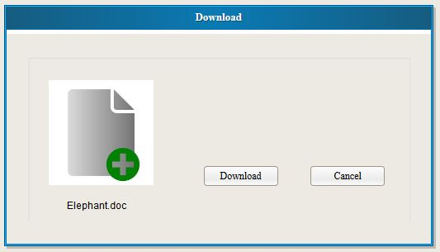

23. Remove User

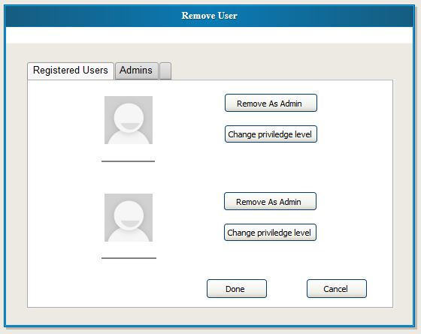

24.Add User

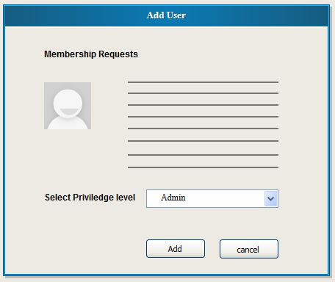

25. Change Priviledge levels by admin

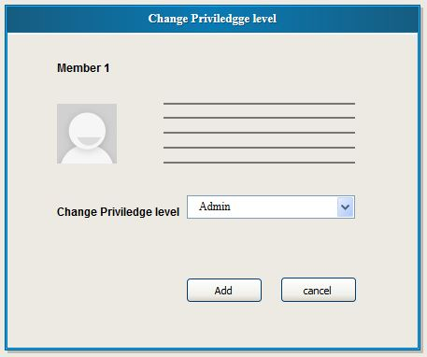

26. Remove posts by admin

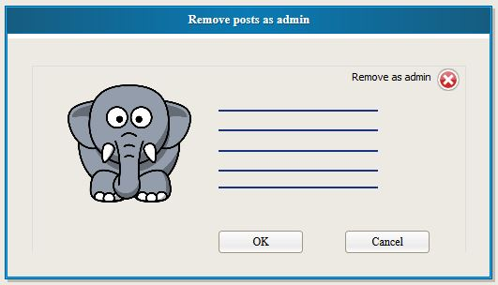

27. Edit Comments By admin

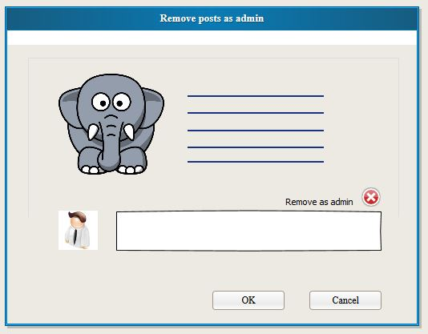

Group Members

ICT 09/10/051 D.R.T.Thilanka 2493

ICT 09/10/041 M.R.R.Y.W.Ranathunga 2482

ICT 09/10/049 D.M.M.A.D.Sumanarathna 2491

ICT 09/10/020 M.G.L.L.Jayasekara 2461

ICT 09/10/058 D.M.A.Kotikawatta 2468

ICT 09/10/011 M.G.S.S.Gunarathna 2454